Authentication and Sessions
Introduction and Lab Report
Lab: Username enumeration via different responses
Prepared by: Nihar Mane

INDEX
Part 1 — Introduction
1.1 What is Authentication?........................................................................................ 2
1.2 Authentication Factors.......................................................................................... 2
1.3 Digital Certificates................................................................................................ 2
1.4 MFA vs. 2FA........................................................................................................ 2
1.5 Authentication vs. Authorization.......................................................................... 2
1.6 SSO / SAML / OIDC............................................................................................ 2
1.7 Login..................................................................................................................... 2
1.8 Session State......................................................................................................... 3
1.9 Logout................................................................................................................... 3
1.10 Reset Flows......................................................................................................... 3
Part 2 — Lab Report Template
2.1 Report Metadata.................................................................................................... 4
2.2 Executive Summary.............................................................................................. 4
2.3 Scope..................................................................................................................... 4
2.4 Methodology and Root Cause............................................................................... 5
2.5 Step-by-Step Execution........................................................................................ 5
2.6 Impact Assessment.............................................................................................. 13
2.7 Remediation........................................................................................................ 13
2.8 Conclusion.......................................................................................................... 13
References
References................................................................................................................. 14

Part 1 — Introduction
- What is authentication?

Definition

Authentication is a process of verifying someone's or something's identity. Authentication usually takes place by checking a password, a hardware token, or some other piece of information that proves identity.

It's working.

A computer cannot "recognize" a person or another computer the way a human can; the process of authentication relies on objective criteria that a computer can measure. One type of objective criterion involves checking for some quality that the person or computer in question is known to have. Another involves the use of a technology called public key cryptography to prove identity.

1.1 Authentication factors—Characteristics that can be verified using existing records
- Something you know (password, PIN, security question)
- Something you have (soft tokens like SMS/app codes, or hard tokens like USB/Bluetooth keys—hard tokens are generally considered more phishing-resistant since they can't be remotely intercepted)
- Something you are (biometrics: face, retina, fingerprint, voice)
- Some frameworks add location and time as supplementary factors.
1.2 Digital certificates—a signed file containing a public key, used to prove an entity holds the matching private key. This is how TLS/SSL and DKIM authenticate servers and domains rather than individual people.
1.3 MFA vs. 2FA: MFA requires two or more distinct factor categories—a password plus security questions doesn't count, since both are "something you know." 2FA is just MFA using exactly two factors, typically knowledge + possession.
1.4 Authentication vs. authorization: Authentication confirms who you are; authorization determines what you're allowed to do once verified—a distinction directly relevant to access control testing.
1.5 SSO/SAML/OIDC: Single sign-on lets a user authenticate once via an identity provider, which then issues assertions to downstream apps—SAML (XML-based) and OIDC (JSON-based) are the two dominant protocols for this.
- Login
Logging in (or logging on, signing in, or signing on) is the process by which an individual gains access to a computer system or program by identifying and authenticating themselves.
- Session state
Session state is a way to save user data across web page requests or app script reruns. Because web protocols like HTTP are stateless, session state uses temporary memory or cookies to remember inputs, choices, and variables for each specific user.
It's working.
- Bypasses stateless limits: Web requests normally treat every click as brand new.
- Tracks unique users: Systems assign a unique ID to match data to the correct person.
- Saves temporary variables: Items like form inputs or game scores stay stored in memory.
- Clears automatically: Data disappears when the session times out or ends.

- Logout
Logout (or logging out or signing out) is the process of terminating a session after an individual is identified and authenticated.

- Reset flows
The sequence a user goes through when they've forgotten their password and need to regain account access without knowing their current one.
Typical steps
- The user clicks "Forgot password" and submits their email/username
- The server generates a reset token (a unique, usually random, string) and stores it associated with that account
- Server emails a link containing the token (e.g., https://site.com/reset?token=abc123)
- The user clicks the link and lands on a reset form
- The user submits a new password
- The server validates the token, updates the password, and—critically—invalidates the token so it can't be reused

PART 2 -> Lab Report

2.1 Report Metadata
Lab Name | Username enumeration via different responses
Provider | PortSwigger Web Security Academy
Vulnerability class | Authentication → username enumeration via response discrepancies → credential brute-forcing → account takeover
Difficulty | Apprentice
Target | PortSwigger Web Security Academy training instance
Tools used | Burp Suite Community Edition v2026.7.3, Burp Intruder (Sniper attack mode), Burp's built-in browser
Test account | None known at start—discovered via enumeration (username: ak)
Date tested | 12 August 2026

2.2 Executive Summary
This engagement examined the login functionality of the “Username enumeration via different responses” lab on the PortSwigger Web Security Academy. The application's /login endpoint returns a distinguishable response depending on whether a submitted username exists: non-existent usernames receive an “Invalid username” message, while existing usernames receive an “Incorrect password” message. These two messages differ in content and, critically, in response length—a difference small enough to miss by eye but trivial to detect automatically.
Using Burp Intruder in Sniper attack mode, the candidate username list supplied by the lab was submitted against the login endpoint with a fixed password, and the results were sorted by response length. One username (ak) produced a response 2 bytes longer than every other candidate, confirming it as a valid account. A second intruder attack was then run against the discovered username, this time cycling through a candidate password list. Sorting by HTTP status code isolated a single request that returned 302 Found (a successful login redirect) rather than 200 OK (a re-rendered login form), revealing the correct password: 112233.
Logging in with AK/112233 authenticated successfully, and the lab was marked solved. This demonstrates that inconsistent login error responses allow an attacker to enumerate valid accounts and then focus password-guessing effort exclusively on confirmed usernames, substantially increasing the efficiency and success rate of a credential-guessing attack.

2.3 Scope
• In scope: the login form and /login endpoint of the PortSwigger Web Security Academy lab instance, including response content, response length, and status codes returned for varying username/password combinations.
• Out of scope: all other functionality of the lab, the underlying infrastructure that hosts it, and any system outside the training environment provided by PortSwigger.
• Testing was performed on a training instance provided and authorized by PortSwigger for this exercise. No real accounts, real credentials, or production systems were involved at any point.

2.4 Methodology and Root Cause
A well-designed login flow should return an identical, generic message (e.g. “Invalid username or password”) regardless of whether the submitted username exists, so that an outside observer cannot distinguish a valid account from an invalid one. This application instead branches its response depending on username validity: unknown usernames receive “Invalid username,” while known usernames receive “Incorrect password.” Because these two strings differ in length, the overall HTTP response length differs by a small but consistent margin — in this case just 2 bytes — which is enough for an automated tool to detect even though it is invisible to a human skimming the page.
This turns the login endpoint into a binary oracle: submit a candidate username, observe the response length, and learn whether that username is valid — without ever needing a correct password. Once a valid username is confirmed, a second automated attack can focus exclusively on guessing its password, and the login response itself reveals success (HTTP 302 redirect to /my-account) versus failure (HTTP 200, login page re-rendered) without any additional guesswork.
The methodology followed was:
• Capture a baseline POST /login request in Burp Proxy's HTTP History and send it to Intruder.
• Clear the default payload markers and set the username parameter as the sole payload position (Sniper attack).
• Load the lab-supplied candidate username wordlist as the payload set and run the attack.
• Sort results by response Length to isolate the outlier response, and confirm via the Response tab that it corresponds to an “Incorrect password” message rather than “Invalid username.”
• Start a second Intruder attack against /login, this time fixing the username to the confirmed value and marking the password parameter as the payload position.
• Load the lab-supplied candidate password wordlist and run the attack.
• Sort results by status code / length to isolate the single request returning a 302 redirect, revealing the correct password.
• Log in using the recovered username/password pair and confirm the lab is solved.

2.5 Step-by-Step Execution

Step 1 — Capture the login request and send to Intruder.
A baseline POST /login request was captured in Burp Proxy and sent to Intruder (Sniper attack) to begin testing the username parameter.
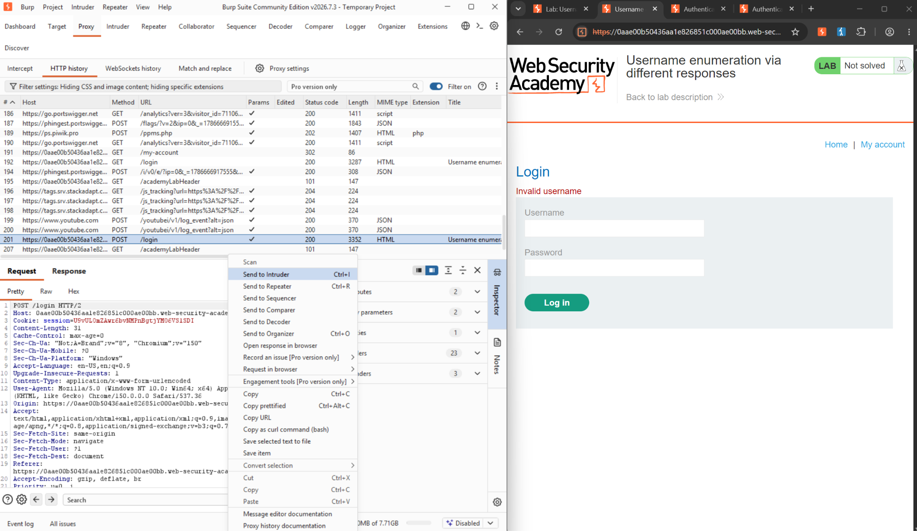
Figure 1: POST /login sent to Intruder, alongside the “Username enumeration via different responses” lab page.
Step 2 — Clear the default payload positions.
Intruder auto-marks every parameter as a payload position by default. These were cleared so that only the username field would be targeted.
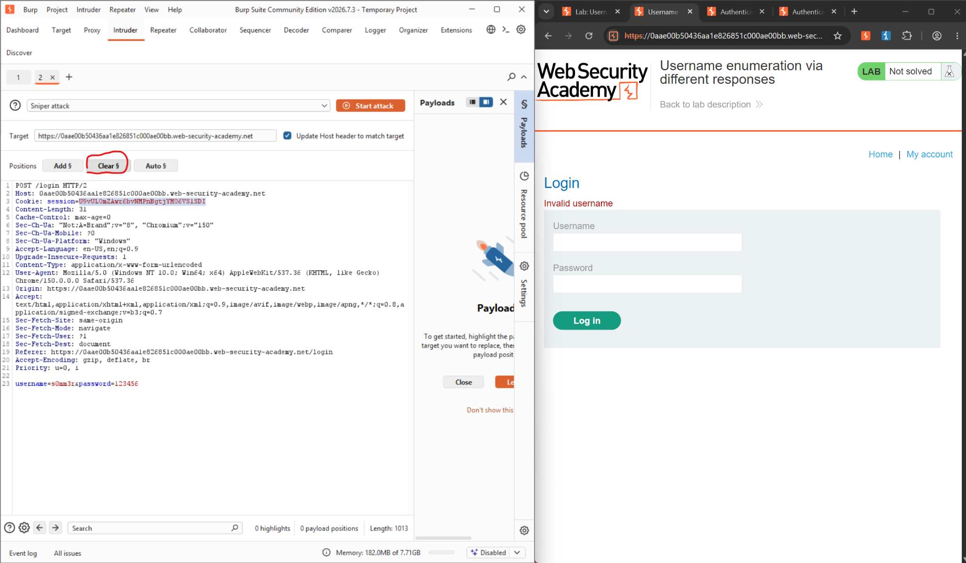
Figure 2: Positions tab with “Clear §” used to remove the default payload markers.
Step 3 — Mark the username as the payload position.
The username parameter's value was highlighted and added back as the sole payload position via “Add §.”
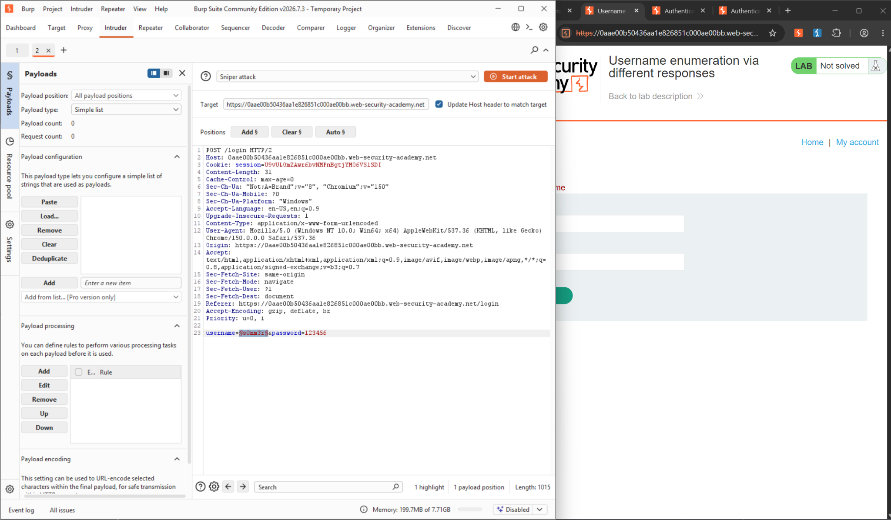
Figure 3: Username value selected and re-added as the single Intruder payload position.
Step 4 — Collect candidate usernames.
The lab provides a list of candidate usernames under the lab description. These were copied for use as the Intruder payload set.
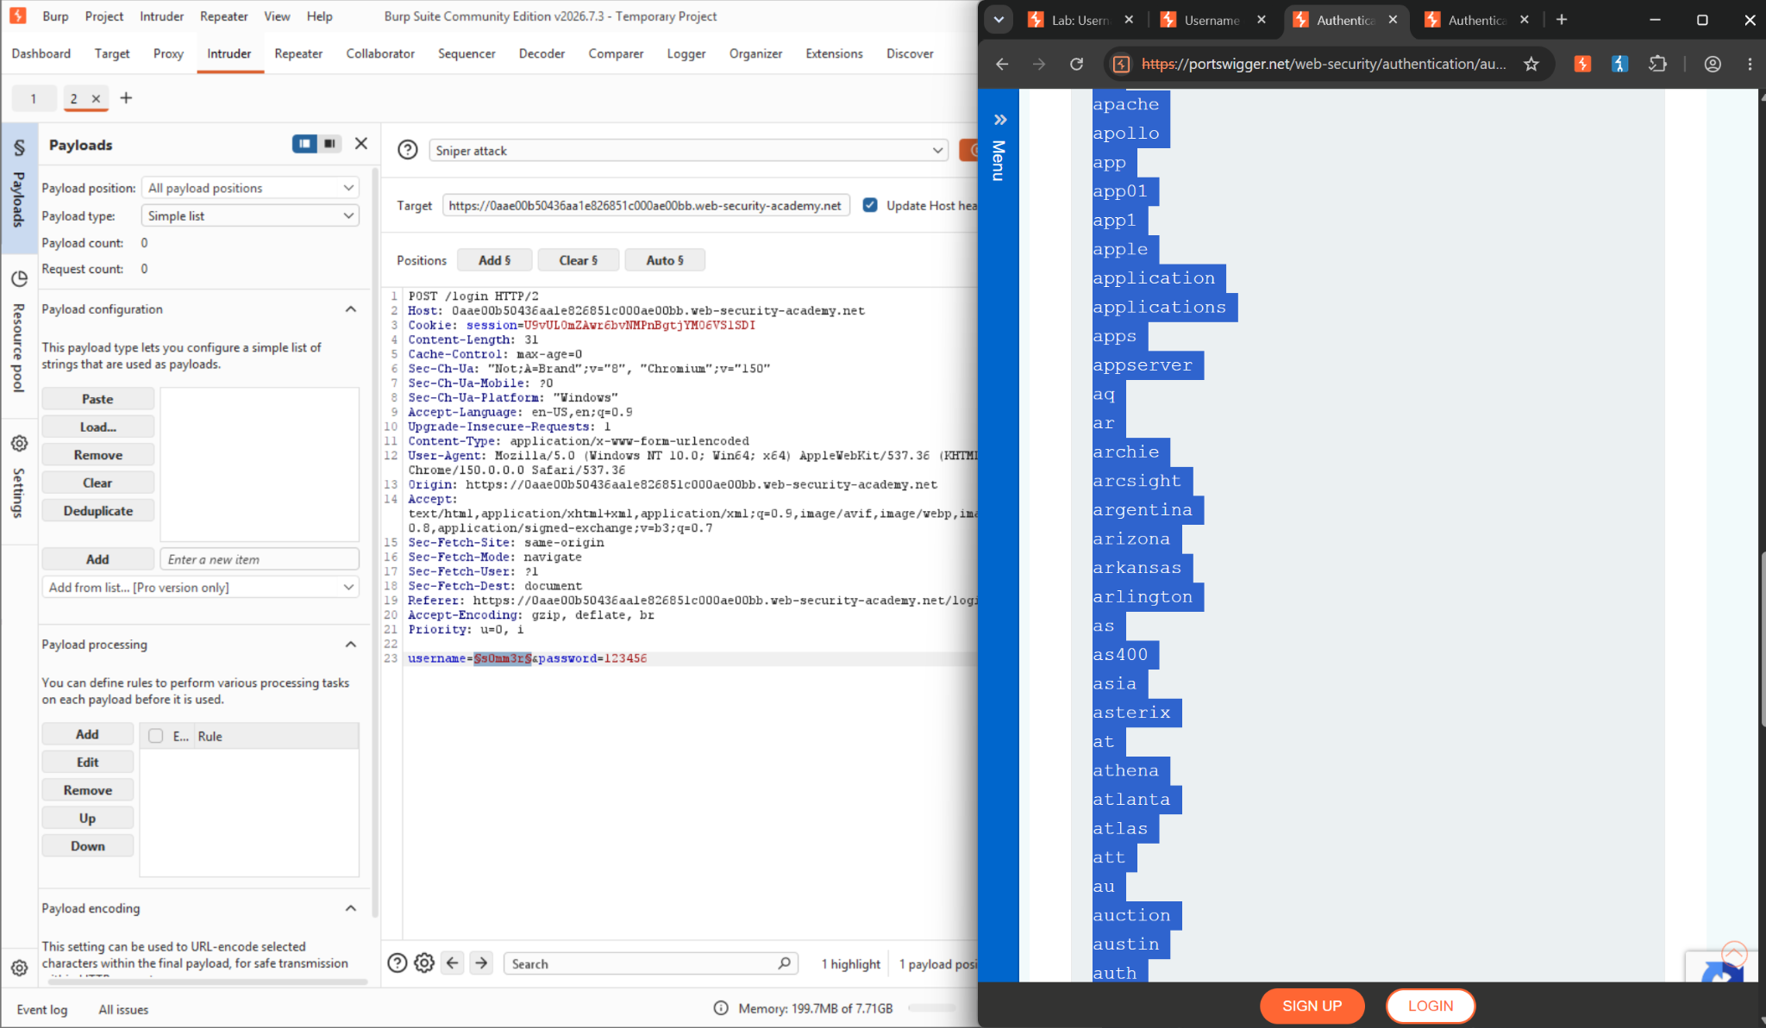
Figure 4: Candidate usernames listed on the lab page, copied for the payload set
Step 5 — Load the usernames into the payload configuration.
The copied usernames were pasted into Intruder's Payloads panel as a simple list.
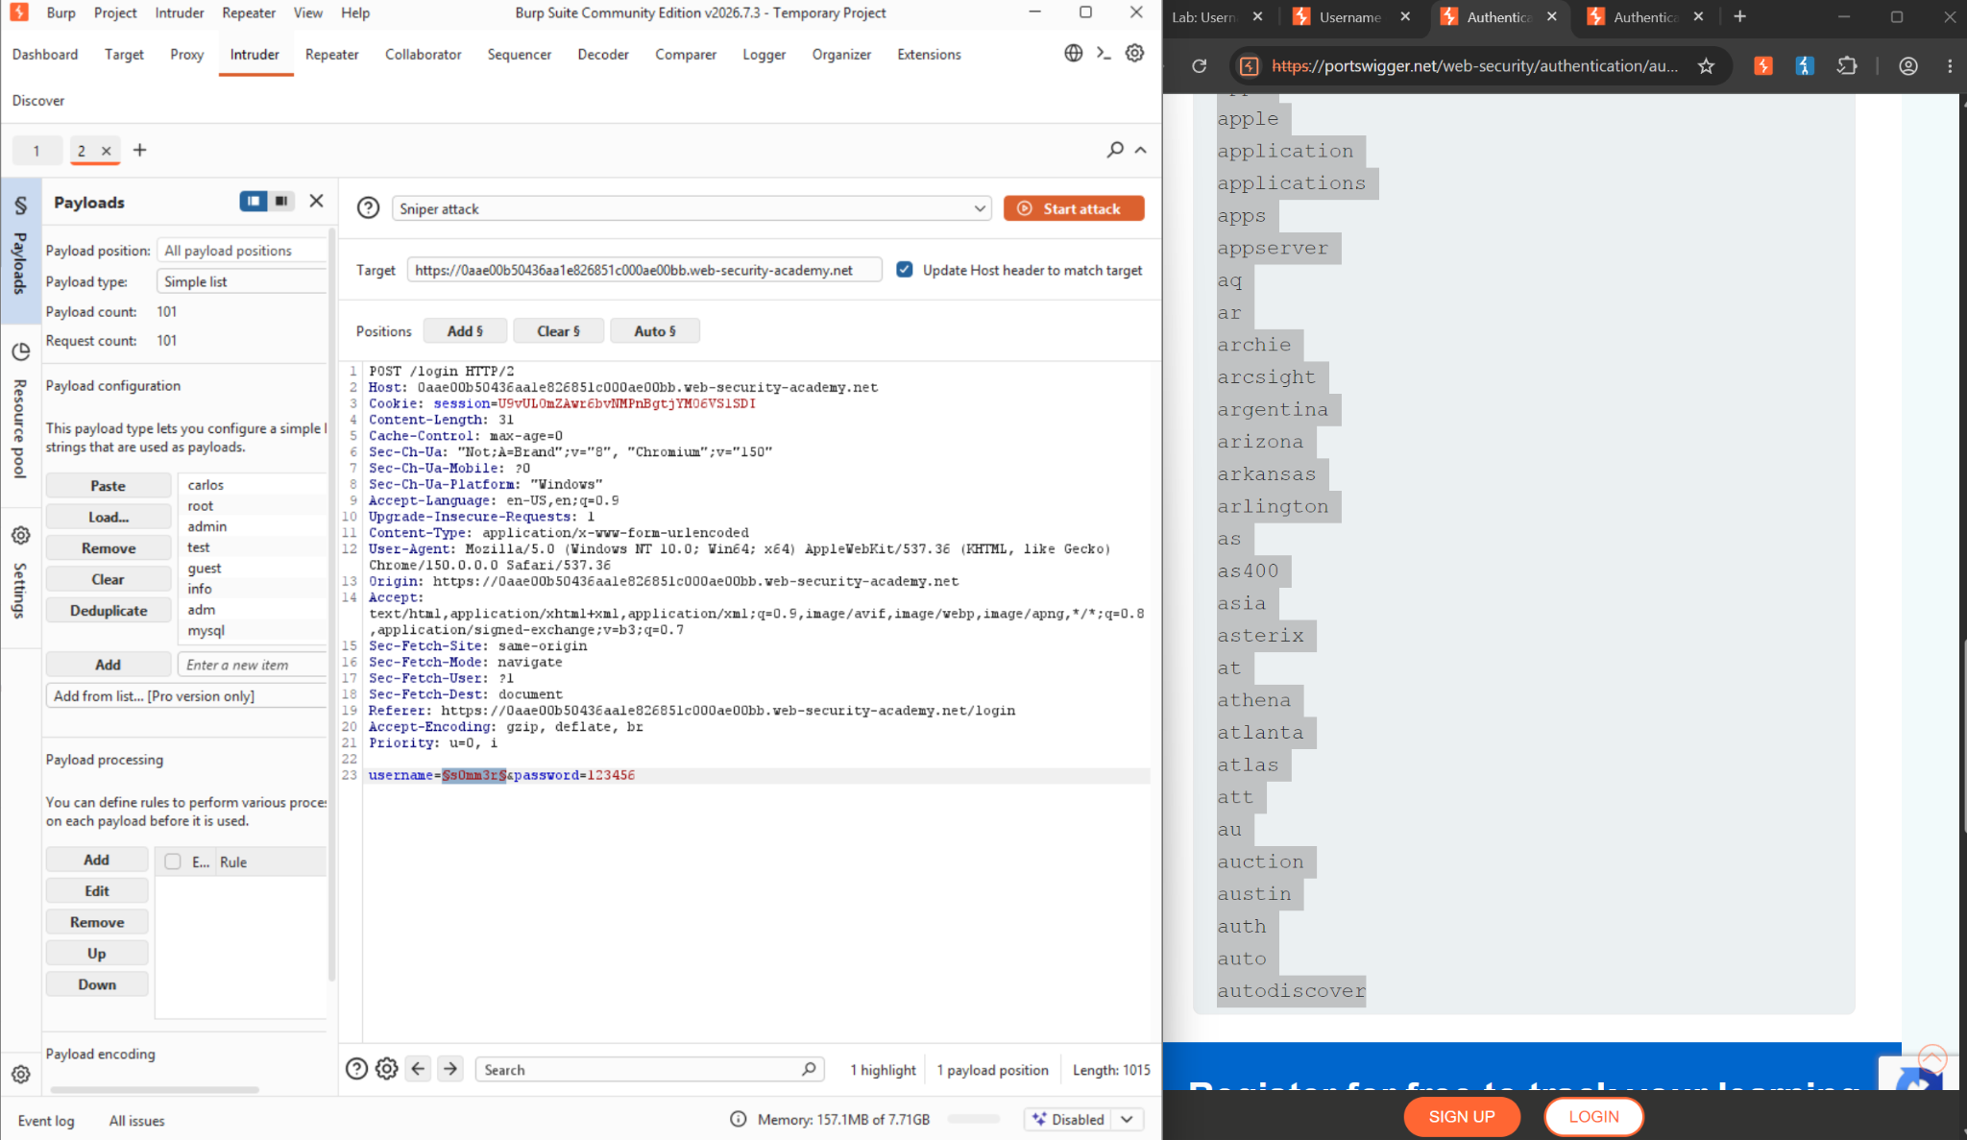
Figure 5: Candidate usernames pasted into the Intruder payload list
Step 6 — Run the attack and sort by response length.
With the attack complete, results were sorted by the Length column. Request 49, payload “ak,” stood out at 3354 bytes versus 3352 bytes for every other candidate — a 2-byte difference caused by the differing response text.
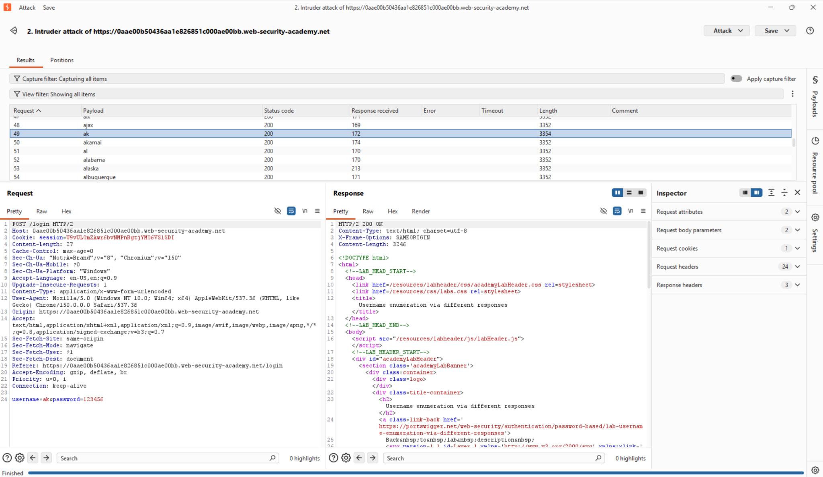
Figure 6: Intruder results sorted by Length; request 49 (payload “ak”) shows a distinct response length of 3354.
Step 7 — Confirm the response content for the outlier.
Inspecting the Response tab for request 49 confirmed the page displayed “Incorrect password” rather than “Invalid username” — proving ak is a valid, existing account.
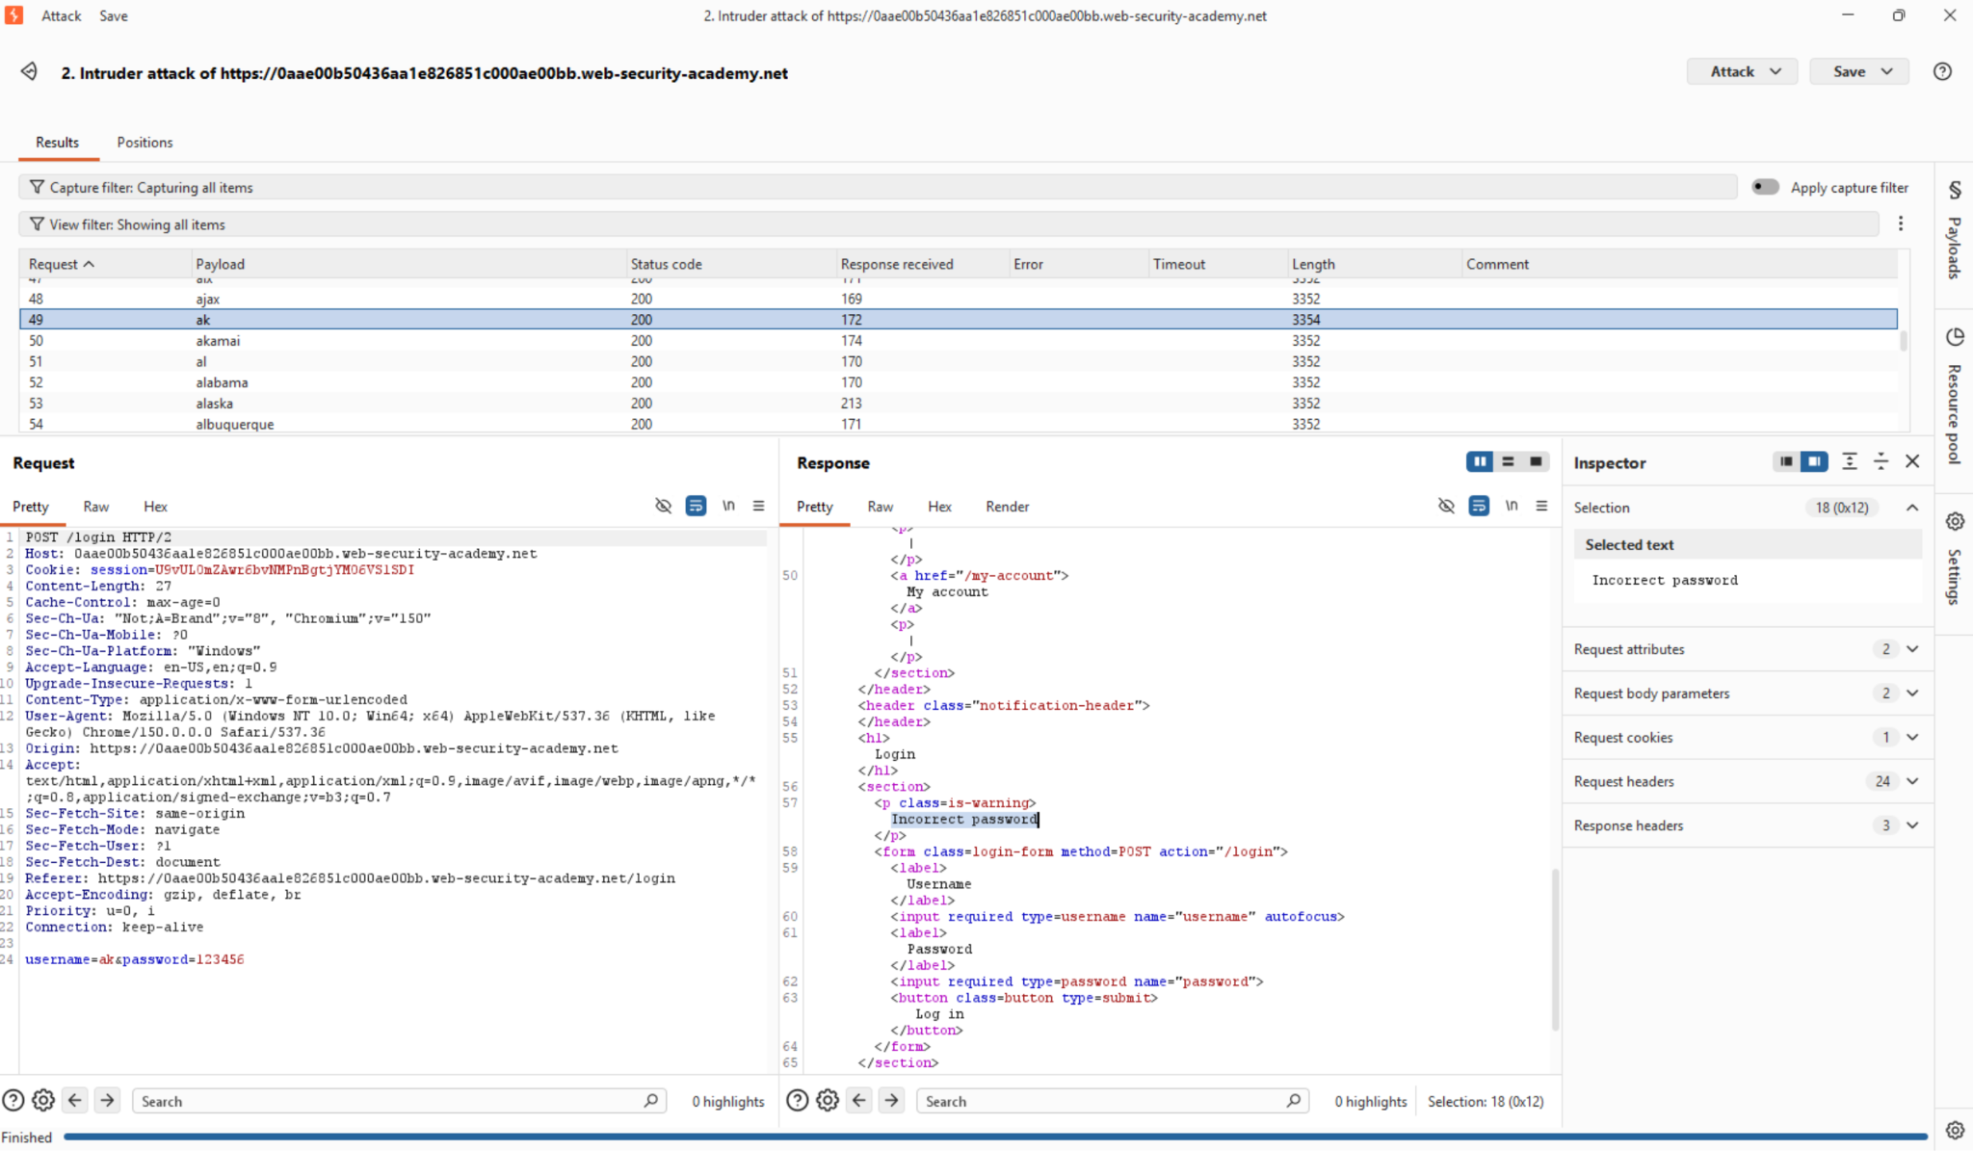
Figure 7: Response for payload “ak” showing “Incorrect password,” confirming the username is valid.
Step 8 — Collect candidate passwords.
With a confirmed valid username in hand, the lab's candidate password list was copied to attack the password field next.
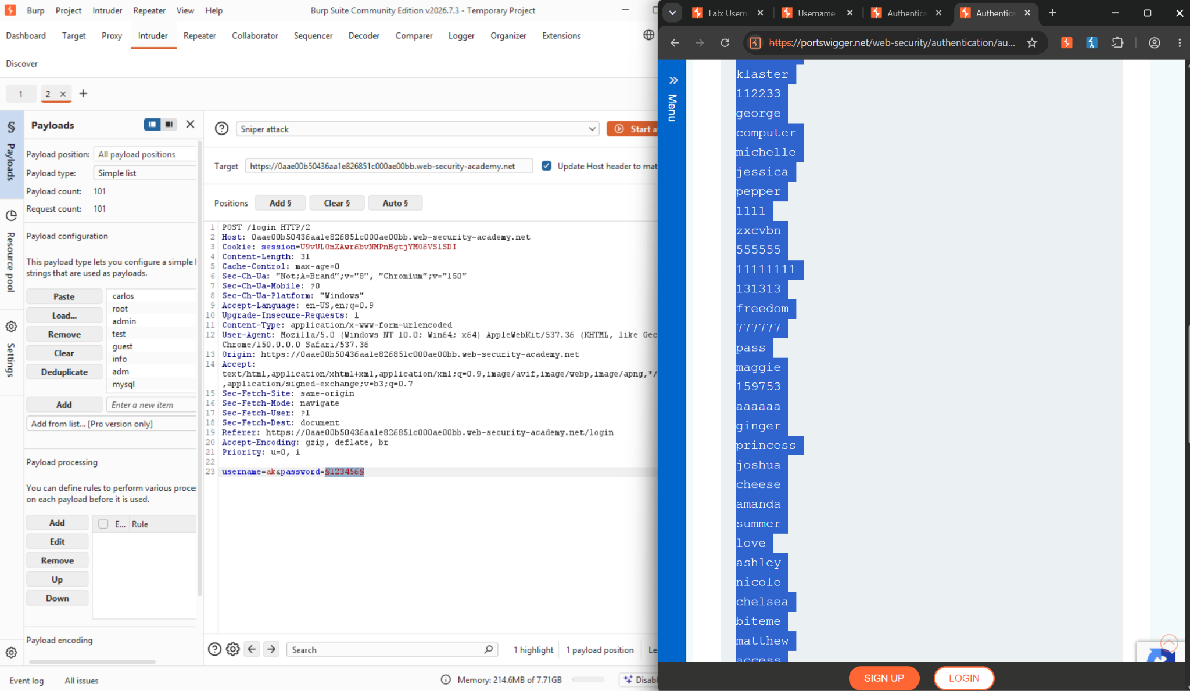
Figure 8: Candidate passwords listed on the lab page, copied for the second payload set.
Step 9 — Run the second attack and identify the successful login.
A new Intruder attack was configured with username fixed to ak and the password parameter marked as the payload position, using the candidate password list. Sorting by Length/Status isolated request 57, payload “112233,” as the only request returning HTTP 302 Found (redirecting to /my-account?id=ak) instead of 200 OK — confirming a successful login.
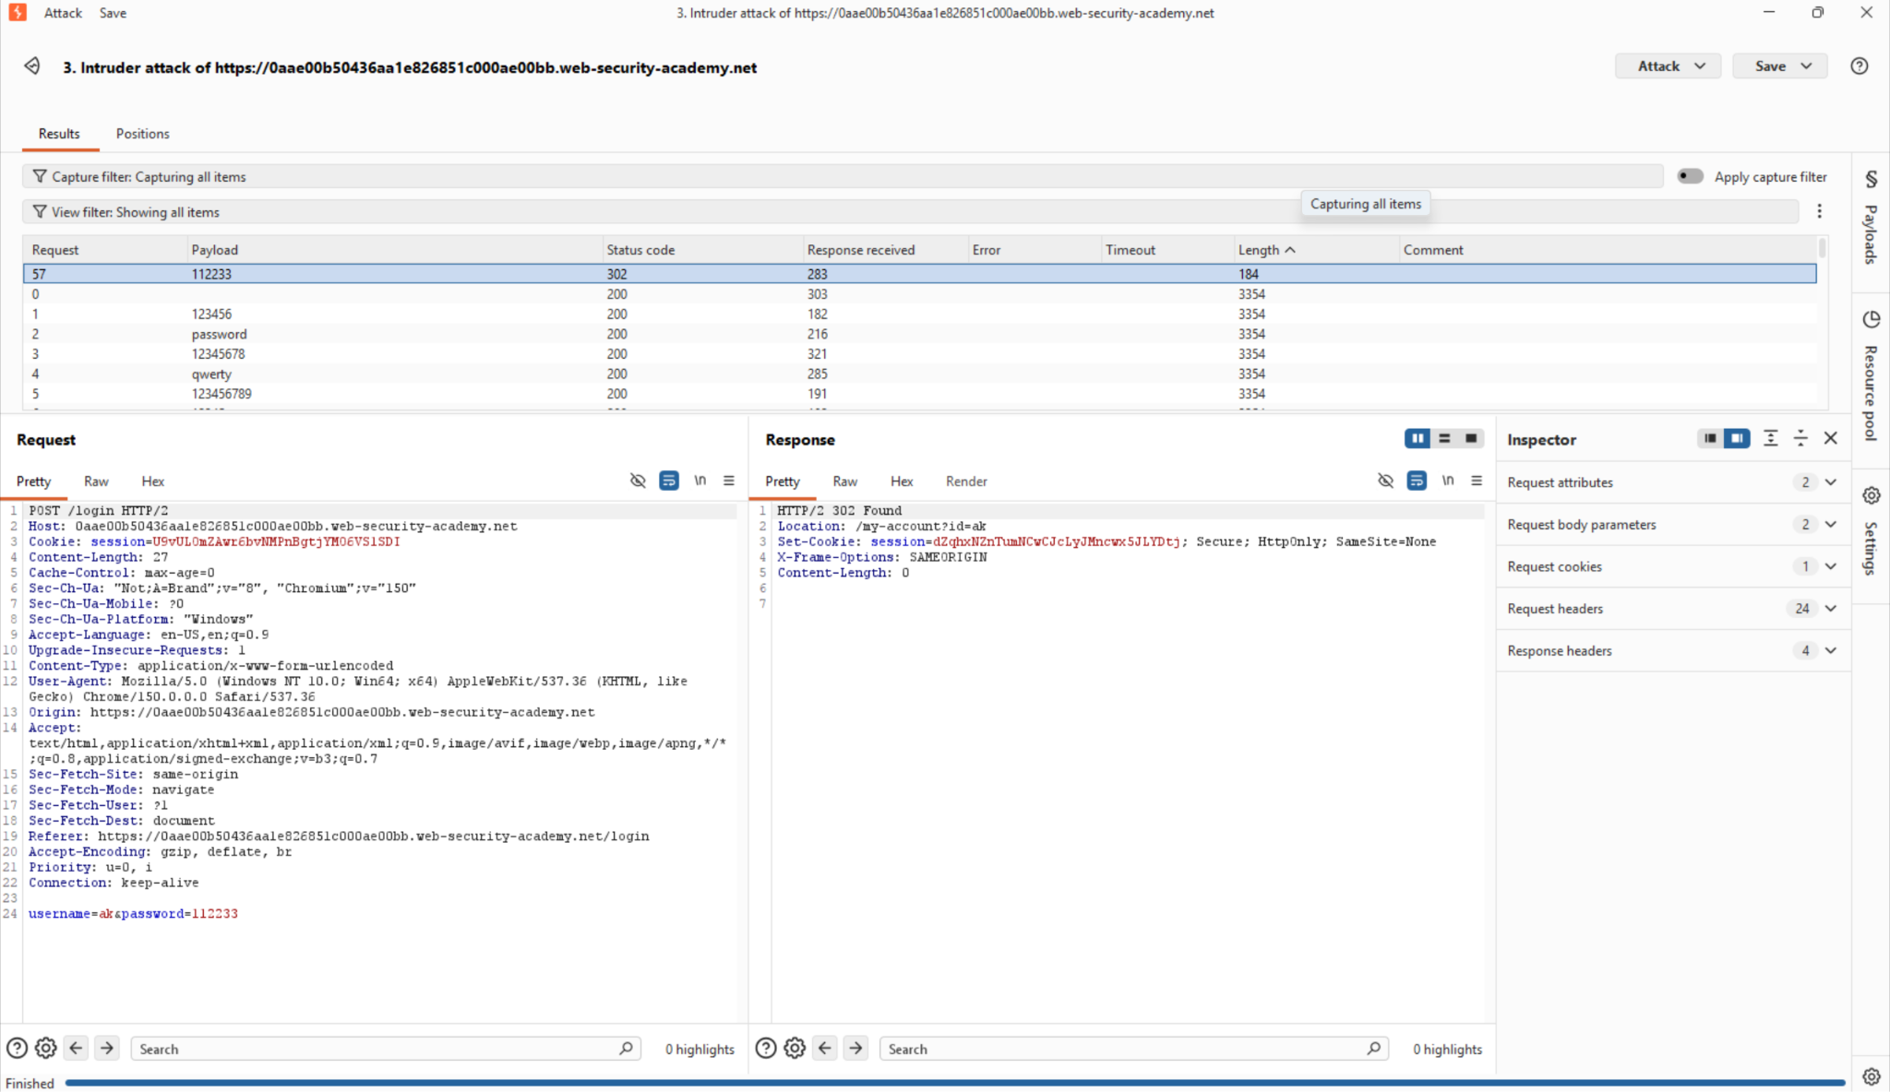
Figure 9: Password attack results: request 57 (payload “112233”) returns a 302 redirect, distinguishing it from every failed attempt.
Step 10 — Log in with the recovered credentials.
The discovered credentials (ak / 112233) were submitted on the live login form to confirm the finding outside of Intruder.
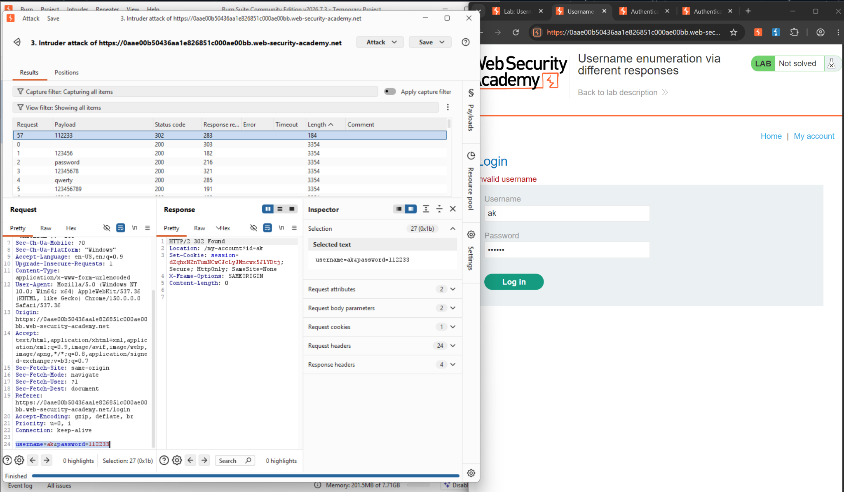
Figure 10: Manual login using the recovered username “ak” and password “112233.”
Step 11 — Confirm the lab is solved.
The application's “Lab Solved” banner and the My Account page (username: ak, email: ak@normal-user.net) confirm the login succeeded, closing the loop from the enumeration in Steps 1–7 to full credential compromise in Steps 8–10.
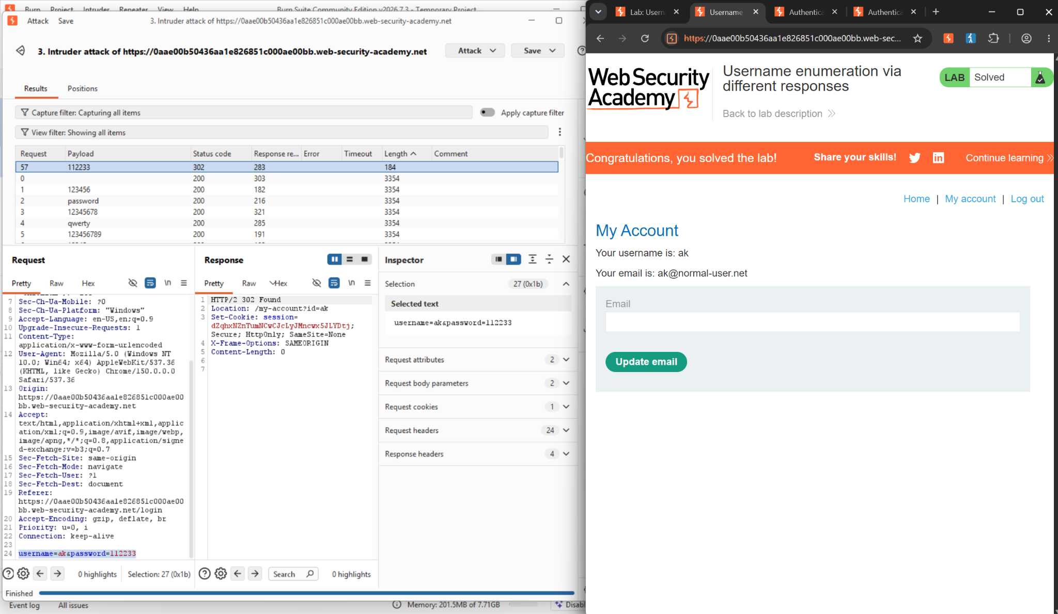
Figure 11: “Congratulations, you solved the lab!” banner with the My Account page for the compromised user ak.

2.6 Impact Assessment
On its own, username enumeration is a moderate-severity issue — it does not directly grant access. Its real danger is as a force multiplier for credential attacks. Without enumeration, an attacker guessing passwords must treat every username as equally uncertain, wasting effort on accounts that don't exist. With enumeration, the attacker first builds a confirmed list of valid accounts, then focuses 100% of password-guessing effort only on those accounts — dramatically increasing the success rate per request and reducing the volume of noisy, easily-flagged traffic.
This lab demonstrated the full chain in miniature: a handful of automated requests confirmed a valid username, and a second automated attack of only 57 requests recovered a working password. In a real deployment with a larger username and password space, the same two-stage technique scales directly — and if the target reuses passwords or uses weak/common ones (as demonstrated here), account compromise becomes a near-certainty rather than a possibility. Because the flaw lives in ordinary login-form behaviour, it is also easy to miss during manual testing and typically only surfaces through exactly this kind of automated response-diffing.

2.7 Remediation
• Return an identical, generic error message for both invalid username and invalid password (e.g. “Invalid username or password”), regardless of which condition actually failed.
• Ensure the underlying response — length, structure, and timing — is also identical between the two failure branches, since a generic message alone is not sufficient if the byte count still differs.
• Implement rate limiting, progressive delays, account lockout, or CAPTCHA after repeated failed login attempts from a single source or against a single account.
• Monitor and alert on login attempts that cycle through many distinct usernames from one source in a short window — a strong enumeration signature.
• Enforce a strong password policy and offer/require MFA, so that even a successfully enumerated username has a low probability of an easily-guessed password succeeding.
• Consider constant-time response handling for the login code path to close off timing-based enumeration as well as content-based enumeration.

2.8 Conclusion
This exercise demonstrated a complete username-enumeration-to-account-takeover chain against the “Username enumeration via different responses” lab. Steps 1–7 established the root cause: the login endpoint's response length and message text differ depending on username validity, letting Burp Intruder isolate the single valid username (ak) out of the full candidate list in one automated pass.
Steps 8–11 built on that finding: with a confirmed valid username, a second Intruder attack against the password field needed only to find the one request returning a 302 redirect rather than a 200 response, recovering the password 112233 without any manual guessing. Logging in with ak / 112233 and reaching the “Lab Solved” state confirmed full account takeover.
Together with the Host Header / password-reset-poisoning work covered in Week 1, this lab reinforces the same underlying lesson from a different angle: authentication flows are only as strong as their weakest observable signal. A header the server shouldn't trust, or a response the server shouldn't let differ, are both cases of the application leaking information it should be keeping to itself — and in both cases, that leak was enough to fully compromise an account.

References
- What is authentication? https://www.cloudflare.com/learning/access-management/what-is-authentication/
- Session state https://learn.microsoft.com/en-us/previous-versions/aspnet/ms178581(v=vs.100)
- Reset flows https://portswigger.net/web-security/host-header/exploiting/password-reset-poisoning
- Username enumeration via different responses https://portswigger.net/web-security/authentication/password-based/lab-username-enumeration-via-different-responses

